**STRUCTURE QUERY LANGUAGE:**

It is a non procedural language which is used to communicate with any database

such as Oracle, sqlserver etc.

* This Language was developed by the German Scientist Mr. E.F.Codd in 1968
* ANSI (American National Standard Institute) approved this concept and in

1972 sql was released into the market

**Features of SQL:**

* SQL is not a case sensitive language it means that all the commands of Sql are not case sensitive
* Every command of sql should ends with a semicolon (;) (It is exemption for SQL Server)
* SQL can be pronounced as Sequel (Structured English Query Language)
* SQL can be called as Common Language Interface, which is used to communicate with any type of database
* SQL can be called as NLI (Natural Language Interface). It means that all the SQL Commands are almost similar to normal English language
* Structured query language is mainly divided into 4 sub languages

**1. DDL (Data Definition Language)**

**2. DML (Data Manipulation Language)**

**3. TCL (Transaction Control Language)**

**4. DCL(Data Control Language)**

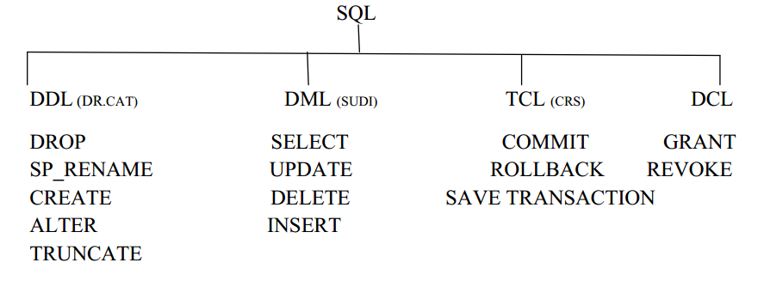

**DATA DEFINITION LANGUAGE**

Data Definition Language: This is a 1st sub Language in SQL which is used to define the database objects such as table, view etc.

* This language contains five commands

1. Create

2. Alter

3. SP_Rename

4. Truncate

5. Drop

**1. Create:**

* This command is used to create the database objects within the database

Syntax: CREATE TABLE <TABLE NAME>

(COL 1 DATA TYPE (size),

COL2 DATA TYPE (size),

:

:

:

:

COLN DATA TYPE (size));

Ex: CREATE TABLE EMP (EID Int, ENAME Varchar (15), SAL

DECIMAL (6, 2));

**Rules for Creating a Table:**

* Table name must be unique under the database.
* Never start table name with numeric or special characters except underscore’_’.
* Do not use space in table name if we want give space in table name then use underscore symbol only.
* Every table name should contain minimum one character to maximum 128 characters.
* The maximum no. of columns a table can have 1024 columns.

**2. ALTER:**

* This command is used to modify the structure of a table using this command, we can perform four different operations
* Using this command we can increase (or) decrease the size of the data type & also we can change the data type from old data type to new data type
* We can add a new column to the existing table
* We can change the column name from old column name to new column name
* We can remove the column from the existing table
* This command contains 4 sub commands

**1. ALTER- ALTER COLUMN**

**2. ALTER- ADD**

**3. SP_RENAME**

**4. ALTER- DROP**

**a. ALTER-ALTER COLUMN:**

* Syntax: ALTER TABLE <TABLE NAME> ALTER COLUMN

<COLUMN NAME> DATA TYPE (SIZE)

* Ex: ALTER TABLE EMP ALTER COLUMN ENAME char (25);

**b. ALTER-ADD:**

* Syntax: ALTER TABLE <TABLE NAME> ADD <COLUMNNAME >DATA TYPE(size);
* Ex: ALTER TABLE EMP ADD DEPTNO int;

**c. ALTER-DROP:**

* Syntax: ALTER TABLE <TABLE NAME> DROP COLUMN <COLUMN NAME>;
* Ex: ALTER TABLE EMP DROP COLUMN SAL;

**d. SP_RENAME:**

* Syntax: SP_RENAME ‘TABLENAME.OLDCOLUMN’,’NEW COLUMN

NAME’,’COLUMN,;

* Ex: SP_RENAME ‘EMP.SAL’,’SALARY’,’COLUMN’

**3. SP_RENAME:**

* This command is used to change the table name from old table name to new table name

Syntax: SP_Rename ‘old table name’,’ New table name’

Ex: SP_Rename ‘EMP’,’EMP1’

**4. TRUNCATE:**

* This command is used for to delete all the records from existing table permanently
* Syntax: TRUNCATE TABLE <TABLE NAME>
* Ex: TRUNCATE TABLE EMP;

**5. DROP:**

* This command is used to remove the table permanently from the database
* Syntax: DROP TABLE <TABLE NAME>
* Ex: DROP TABLE EMP;

Note: SP_help: This command is used to see the structure of table

* Syntax: SP_help <table name>
* Ex: SP_help EMP

Note: Syntax to view tables in the current database.

* select * from sysobjects where XTYPE='u'